ACCESS AMC ADLS (EPIC Course)
Note: Must use internet explorer browser and be on a .mil network to register for new ADLS account. Once your ADLS account is created you can login from any network PC .com or .mil with CaC reader.

A. FIRST PERFORM PC SET UP (required for all ADLS courses to operate correctly) If this is not completed the course will not track your progress or mark completed. These steps are requires on any PC you login with to complete training. These steps may also need to be recompleted due to Internet Explorer updates.
SET UP COMPATIBILITY MODE
- Right mouse click on internet explorer top window bar/ make sure (Command bar) is checked on
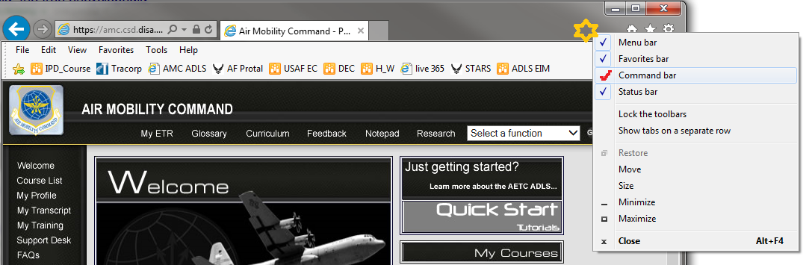
- Select menu (Tools) and select (Compatibility View Settings) in Dropdown menu.
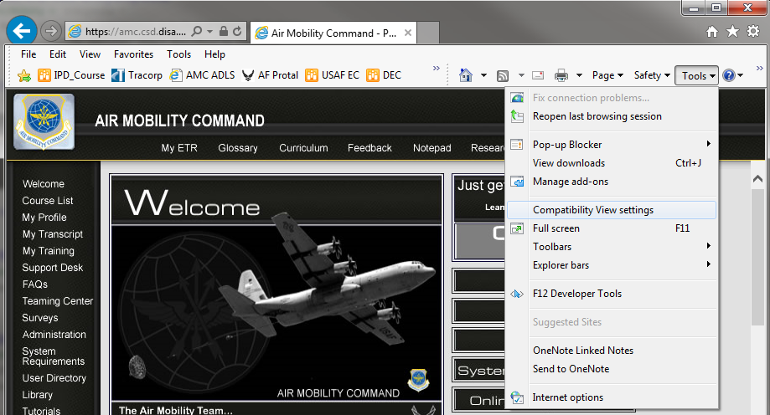

- Type in af.mil then click on (Add) to place into compatibility view box then select (Close).
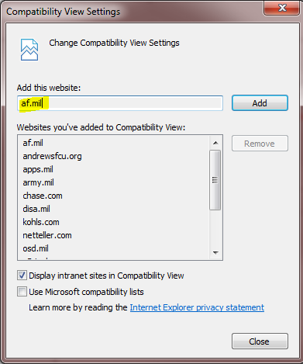

CLEAN OUT IE BROWSER TEMP FILES
- On Internet Explore window menu select (Tools) then select (Internet Options)

- Select (Delete)
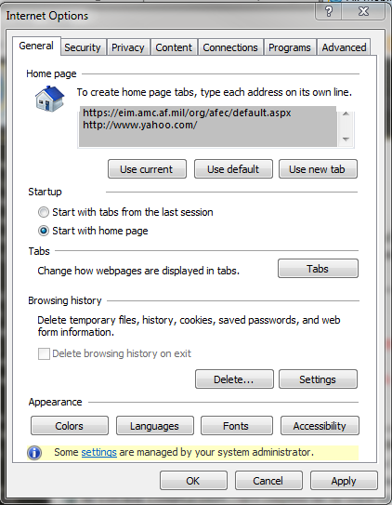
- Select (All Checkboxes – you can) then select (Delete)
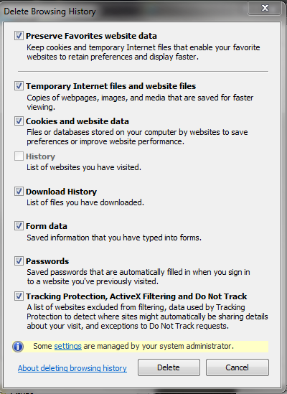

- Select (Settings)
- Select (View files)
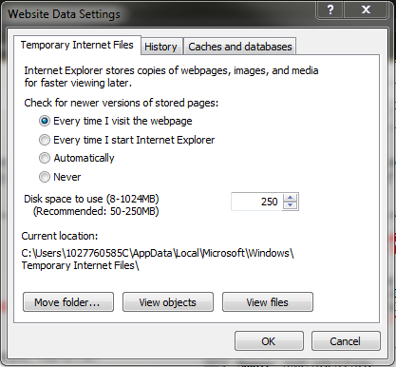

- Select all files in window and delete them (use delete key on keyboard)
/close window then select (OK button) to close out above internet options windows.
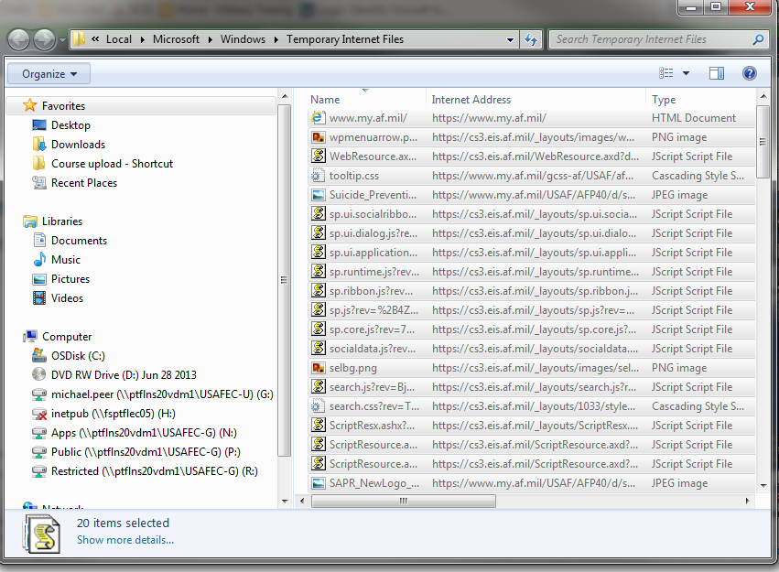
B. CREATE ADLS ACCOUNT/RETRIEVE ACCOUNT (If not required skip to C.)
(New User Registration) must use .mil PC:
1. Select (Registration) button at: https://golearn.adls.af.mil
2. Enter personal info through the DEER's interface.
Note: You may be notified you already have an account. (Go to Retrieve Username/Password) below.
3. Enter the login ID and password to create the account. (both are case sensitive)
4. Select your org by clicking on either the “search by name” or “search by tree” button to find your unit.
5. Click on the unit name to view sub unit/organizations then select click here to select the current organization level (select the level that is available, if the unit is not listed select the higher level).
6. Fill out your profile information, make sure to use the correct email addresses for your and the Unit Training Manager (UTM) this can be your supervisor information.
7. Set up challenge question answers.

(To Retrieve Username/Password)
1. Select (Username/Password) button then (Forgot your username or password) (both are case sensitive)
2. Enter personal info through the DEER's interface.
You will be provided your username and if needed link to answer challenge questions to reset password.
3. After successful retrieval you can login with (username/password) on home page.

C. NAVIGATE TO FIND THE COURSE
Username/password login is only available on .mil connection. AMC ADLS is accessible through a .mil network or .com connection with a CaC card reader once your account has been created.
(Once logged into the AF ADLS) click on (ADLS Gateway link) left menu to navigate to derivate launch menu.

1. Click on AMC Patch (Picture) to be directed to the AMC site.
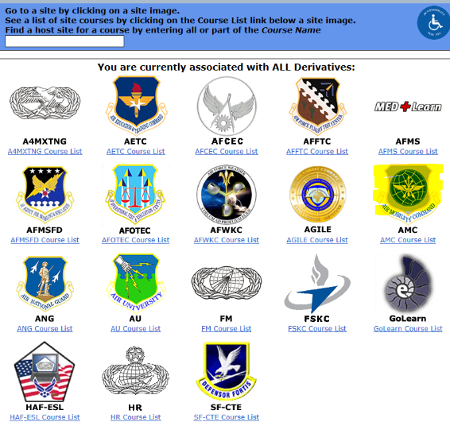

- Click on “Course List” on top left hand navigation pane.
- Expand the list of “Expeditionary Mobility (101 LvL)” courses.
- Select “Equipment Preparation Introductory Course (EPIC)” title.
- Select (Take/Resume) Button to launch course.

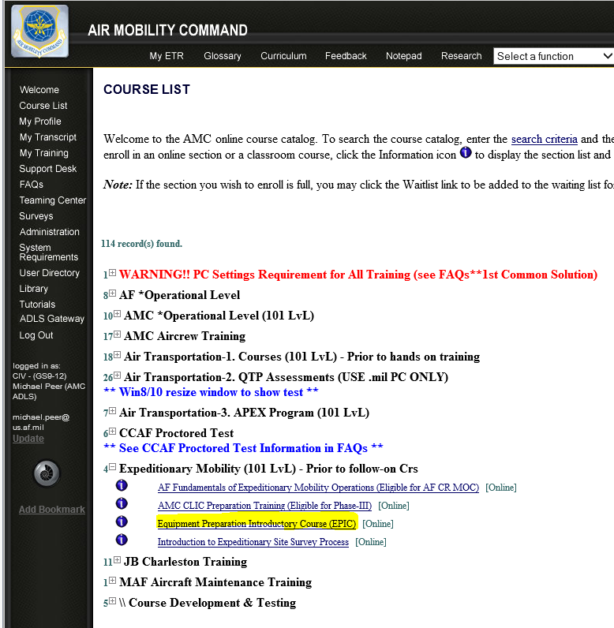
(note: always print out assessment score if you need to have your record updated by the helpdesk).
5. Once training is completed certificate is located under (My Transcript) left side menu.
For any assistance contact the AMC helpdesk at: AMCDistance.Learning@us.af.mil

